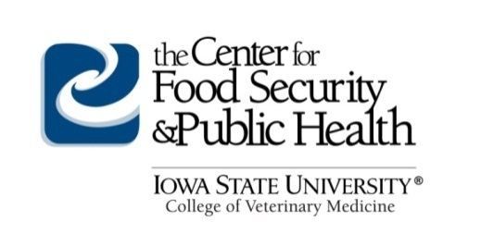
For Immediate Release
Source: Center for Food Security and Public Health
College of Veterinary Medicine
Iowa State University
YouthInAg@iastate.edu
Press Contact: Abbey Canon, DVM, MPH, DACVPM: acanon@iastate.edu or Telephone 515-294-2035

Excellence in Exhibition: Preventing Disease in Animals and People
A Free Online Course for Youth in Animal Agriculture

Ames, IA – The Center for Food Security and Public Health at Iowa State University’s College of Veterinary Medicine created an online course to teach youth about zoonotic diseases, “Excellence in Exhibition: Preventing Disease in Animals and People”. Targeted at youth aged 13–18 years, the free online course is meant to encourage showmanship and animal involvement while keeping both animals and humans safe and healthy.

Raising and showing livestock help youth develop responsibility, learn good sportsmanship, and gain confidence. While raising and showing animals have an overall positive impact on youth and the community, there are many animal diseases that can be spread between people and animals, especially when people have close contact with animals. Several animal related disease outbreaks, such as variant influenza A virus of swine (H3N2v) and enteric disease outbreaks caused by pathogens such as E. coli, have been associated with fairs in recent years. In many instances, these events resulted in severe illness in youth. Youth livestock projects can also present disease transmission risks to animals due to the comingling of various animals and animal species from different locations.

Understanding disease risks and preventive measures is critical to reduce the occurrence of zoonotic diseases among youth associated with animal agriculture. Awareness of these risks can help youth to understand the importance of disease prevention for themselves, their animals, and the public. Additionally, teachers, volunteer leaders, and parents should understand the same disease risks to further reinforce measures needed to prevent zoonotic disease transmission.

The web-based course includes lessons, case studies, and supplemental materials. It is self-paced and accessible online at any time for participants.

To learn more and to take the course, visit http://www.cfsph.iastate.edu/YouthInAg/.

About the Center for Food Security and Public Health
The Center for Food Security and Public Health (CFSPH) is nationally and internationally recognized for providing educational materials and animal disease information. The CFSPH was established in 2002 through funding from the Centers for Disease Control and Prevention (CDC) to increase national and international preparedness for accidental or intentional introduction of diseases that threaten food production or public health. The CFSPH website (www.cfsph.iastate.edu) is the Number One result on Google searches for “animal disease information,” with more than 450,000 visits annually.

-End-

